Manuscript template for HKSTS conference proceedings

Cover Page

Submission number: _______________________

Title of Manuscript

A. Corrauthor ª, B. author ^{b} and C. Coauthor ^{c}
ª Department of Civil and Environmental Engineering,
The Hong Kong Polytechnic University, China
Email: a.corr.author@polyu.edu.hk
^{b} Department of Civil Engineering, The University of Hong Kong, China
Email: b.author@hku.hk
^{c} ABC Corporation, U.K.
Email: c.author@abcc.uk

Abstract

A single-paragraph abstract of up to 150 words, outlining the aims, scope and conclusions of the paper.

Keywords: (up to five)

Subject area: (Please put a “X” as appropriate, you may choose more than one)

 | a) | Transportation Infrastructure and Built Environment
 | b) | Sustainability Issues in Transportation
 | c) | Travel Behavior Modeling
 | d) | Technology and Information
 | e) | Transport Geography
 | f) | Transport Dynamics
 | g) | Logistics and Supply Chain Management
 | h) | Transport Networks

Preferred mode of presentation: (Please put a “X” as appropriate)
 | Oral presentation only |  | Poster presentation only
 | No preference

Name of presenter/key speaker:

Request for the consideration of publication in the Proceedings: (Please put a “X” as appropriate)
 | Presentation and Publication |  | Presentation only

Submission for HKSTS Outstanding Student Paper Award (You are a postgraduate student and the sole author of the paper): (Please put a “X” as appropriate)
 | Yes |  | No

Submission for HKSTS Outstanding Dissertation Paper Award (You are PhD graduate who is citizen of an Asian country and who has completed your PhD study within three years and the first author of the paper): (Please put a “X” as appropriate)
 | Yes |  | No

Manuscript template for HKSTS conference proceedings

A. Corrauthor ª, B. author ^{b} and C. Coauthor ^{c}
ª Department of Civil and Environmental Engineering,
The Hong Kong Polytechnic University, China
Email: a.corr.author@polyu.edu.hk
^{b} Department of Civil Engineering, The University of Hong Kong, China
Email: b.author@hku.hk
^{c} ABC Corporation, U.K.
Email: c.author@abcc.uk

Abstract

The first section of the paper should be a single-paragraph abstract of up to 150 words, outlining the aims, scope and conclusions of the paper.

Keywords: (up to five)

INTRODUCTION

The full paper, in MS Word compatible format, should be submitted to the online submission system via https://easychair.org/conferences/?conf=hksts2016 by 15 August 2016. Please follow the Notes for Preparing Full Paper and Instructions to Authors: Online Paper Submission available on the Conference Website: http://www.hksts.org/conf.htm and upload the file of your paper to the system. If you cannot submit the full paper electronically, please send a CD containing the full paper by airmail to:

21th HKSTS International Conference Secretary Office
c/o Room 1106-8, 11/F, C C Wu Building
302-308 Hennessy Road, Wan Chai
Hong Kong

Late submissions will not be published in the HKSTS Conference Proceedings.

The manuscript should be in English.

PAPER FORMAT

Margin

Set the paper size to A4 (210 mm wide by 290 mm deep) with 25 mm margins on all sides.

Fonts

Font size is Times New Roman typeface in 11 point pitch. For paper title, please set Bold and ALL CAPITALS.

Single Spacing

Paper Length Limit

The paper length limit is 8 pages maximum, including figures, tables, references, and appendices, but excluding the cover page.

Paragraphing

- Leave a blank line between paragraphs without indent.
- Text should be left and right justified across whole page width, providing a vertical margin on both sides.
- A blank line must be left before each title of the sections and one blank line before each title of the subsections and sub-subsections, with the exception of new pages.

STRUCTURE OF PAPER

Cover page

The cover page of the manuscript must contain the following, and in the order specified below:

- The Paper Title
- Author Name(s) are typed in the sequence of: First name, then Middle name and Surname lastly. Surname is typed in All CAPITALS.
- Institutional Affiliation of the Author(s) (including Department, Name of Organization and Country) and Author email address(es)
- An Abstract
- Up to five keywords
- Subject area
- Preferred mode of presentation: Oral, Poster or No Preference
- Name of Presenter or key speaker
- Request for the consideration of publication in the Proceedings or not
- Submission for HKSTS Outstanding Student Paper Award or not

Second and following pages

These include the main body of the paper, beginning with the title, followed by the name(s) and affiliation(s) of the author(s), then the abstract and keywords.

Positioning of Paper Title, Author Names and Author Affiliations

- Paper title to be centred
- Leave one blank line between the paper title and author names.
- Both author names and author affiliations to be centred.
- Leave two blank lines between author affiliations and abstract.

Main body of paper

The rest of the paper should be divided into sections and (optionally) subsections with sub-subsections. Sections must be numbered and their title typed in bold capitals (for example, 1. SECTIONS). Subsections must be numbered using two digits and their titles typed in bold typeface (for example, 1.1 Subsections). Sub-subsections must be numbered using three digits and their titles typed in bold typeface (for example, 1.1.1 Sub-subsections). Two blank lines must be left before each title of the sections and one blank line before each title of the subsections and sub-subsections, with the exception of new pages.

EQUATIONS, TABLES AND FIGURES

Equations

Equations must be typeset with the same word processor. You may also type the equation in Mathtype (which is available at www.mathtype.com, with 30 days free trial), and use its default setting. All equations must be numbered and appeared in the following format (font type must be TIMES NEW ROMAN):
a + b = c | (1)

Z = Y x (U + B) | (2)

Tables

Tables are to be centred. Tables must be numbered sequentially, with their title centered above the table. Example:
Table 1. Sample of Table
Regions | A | B
Asia | 4 | 50%
Europe | 3 | 40%
Africa | 3 | 20%
America | 4 | 50%

Figures

All Figures will be reproduced in black and white. They must be drawn in ink or with good quality graphic software. Figures are to be centred, with the reference and caption to be centred below the figure. All Figures must be quoted in the text. Example:

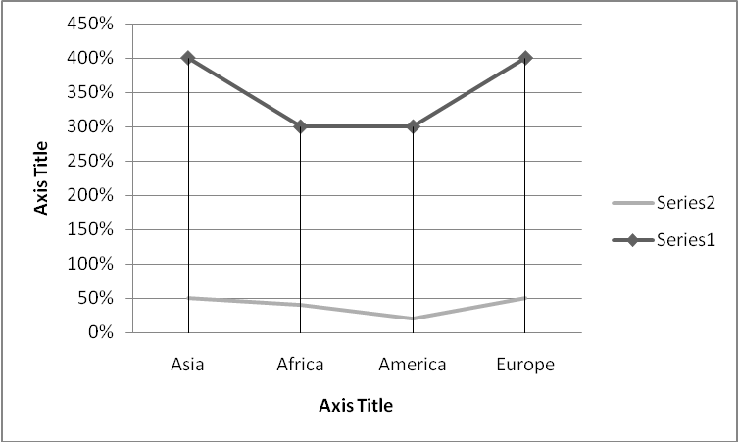
Figure 1. Sample of figure

REFERENCES

The Harvard System of referencing must be used (see, for example, Transportmetrica). In the body of the text, papers or documents are referred to by the author’s surname with the year of publication in parenthesis; if the quotation is itself in parenthesis, the year of publication is separated by a comma. If the reference has more than two authors, only the surname of the first author followed by et al. in italics will appear in the body of the text.

At the end of the paper, complete references must be given alphabetically by author’s surname including: surname(s) and initials of author(s), separated by a comma, year of publication in parenthesis, title of the paper, title of the journal in italic typeface, volume of the journal, and first and last pages. In the case of books, the title of the book must be in italic typeface, with first letter capitals; the publisher and the city of publication must also be indicated. Examples:

Kanafani, A. and Abbas, M.S. (1987) Local air service and economic impact of small airports. Journal of Transportation Engineering ,113, pp. 42-55.
Button, K.J. (1982) Transport Economics. Heineman, London.
Nash, C.A. (1988) Integration of public transport: an economic assessment. Bus Deregulation and Privatisation: An International Perspective, eds J.S. Dodgson and N.P. Topham, pp. 17-46. Wiley, New York.
Grant, R.A. (1989) Building and testing a causal model and information technology’s impact. Proceedings of the Tenth International Conference on Information Systems, Boston, MA, pp. 173-184.
Cardell, N.S. (1989) Extensions of multinomial logit: the hedonic demand model, the nonindependent logit model and the ranked logit model. Ph.D. Thesis, Harvard University, U.S.A.

